ME 5370 – Mechatronics
Lab – 5

Matthew O’Kane

Stephen Canfield

This is the fifth lab, with the goal of getting familiar with hardware timers and ISR’s (Interrupt Service Routines).
Problem statement:
Your overall objective is to learn about the basic ATMega timer and the ultrasonic sensor. You will assemble the system (atmega, ultrasonic ranger), implement and run the code given (Using Timer function with the Ultrasonic sensor), make sure it is working properly, and review and experiment with the code to ensure a full understanding.
Executive Summary:
This lab introduces the basic timer and ISR capabilities of the ATmega2560 microcontroller through the development of a range finder. The project utilizes timer2, an 8-bit timer, to send an activation signal and to receive distance information through overflow and input ISR’s.
The system is designed to display the distance between the ultrasonic ranger (HCSR04) and the object its signal is bouncing off. The system will send a pulse activating the sensor after which the sensor will send out an ultrasonic chirp. When the sensor receives the chirp back, it returns a signal high for the same time it was waiting for the chirp back. The distance is then calculated, using the formulas given in the manufacturer’s data sheet, and then displayed on an LCD.
The main functions of this system are handled by 8-bit timer, timer2. The timer is set with a prescalar of 64, making each timer tick 4 microseconds, and each overflow 1.024 milliseconds. The sensor has a total range of about 4 meters. We can then calculate the maximum time of flight in which the sensor is accurate, about 40 milliseconds. The time for the trigger and echo signals are measured using timer2.
By using previous made libraries, I was easily able to implement the functionality for the sensor and create a timer to recall the sensor properly. This lab practically demonstrates the use of timers and ISR’s to measure time based data.

Equipment Used:
1 - Arduino Mega Board
1 - 16x2 LCD
1 – 220 ohm Resistor
1 – 10k ohm Potentiometer
1 – 63 Channel Breadboard
19 – various length Wires
Pins Used:

5V: Power
GND: Ground
2: ECHO (HCSR04)(INT4)
4: LCD D7
5: LCD D6
6: LCD D5
7: LCD D4
11: LCD E
12: LCD RS
53: TRIGGER (HCSR04)

Schematic:
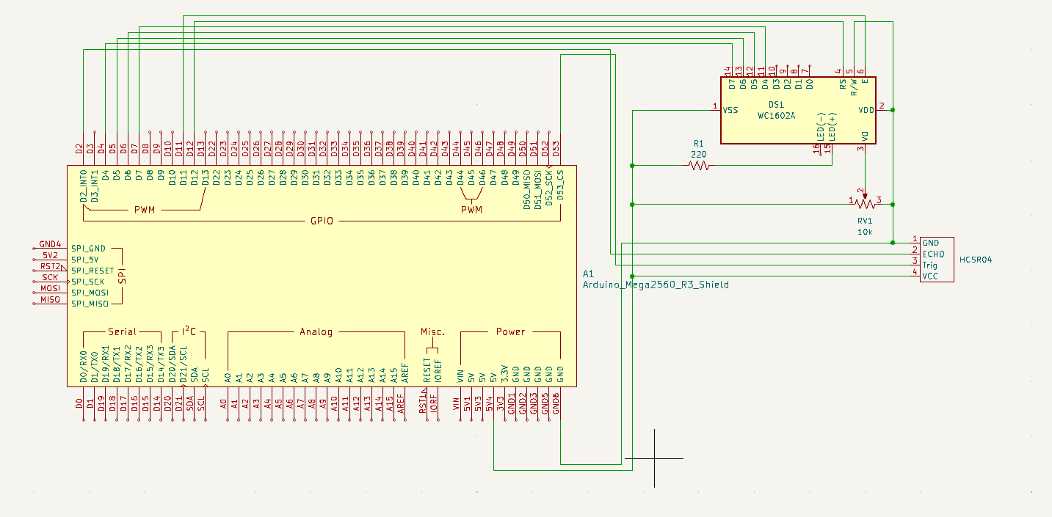
Code:
/*
Title: Lab 5 ME 5370 Mechatronics -
Author: Matthew O'Kane
Date: 3/2/2026

Last Updated: 3/2/2026

//Edits 3/7/26
set prescalar properly, was set at 32 instead of 64
added some safety to the sensor fucntion
//Edits 3/5/26
built most of the functionality for the header files
//Edits 3/4/26
created the skeleton for the header files
//Edits 3/2/26
created the necessary files to run ultrasonic sensor HC-SR04

*/

#include <LiquidCrystal.h>

#include "usHCSR04.h"
#include "timer.h"

const int rs = 12, en = 11, d4 = 7, d5 = 6, d6 = 5, d7 = 4;

uint16_t distance_cm = 0;
uint16_t distance_in = 0;

extern uint8_t flag60ms;

LiquidCrystal lcd(rs, en, d4, d5, d6, d7);

void setup() {
// put your setup code here, to run once:

lcd.begin(16, 2);

setupHCSR04();

timerInit();

}

void loop() {
// put your main code here, to run repeatedly:

if(flag60ms){

getDistance( &distance_cm, &distance_in);

flag60ms = 0;

}

lcd.setCursor(0, 1);
lcd.print(" ");
lcd.setCursor(0, 1);
lcd.print(distance_cm);
lcd.setCursor(4, 1);
lcd.print(" cm ");
lcd.print(" ");
lcd.setCursor(10, 1);
lcd.print(distance_in);
lcd.setCursor(13, 1);
lcd.print(" in");
lcd.setCursor(0,0);
lcd.print("distance");

}
usHCSR04.h:
#ifndef USHCSR04_H
#define USHCSR04_H

#include <stdint.h>

void setupHCSR04(void);

void triggerHCSR04(void);

void getDistance(uint16_t *cm, uint16_t *in);

#endif
usHCSR04.cpp:
/*
The purpose of this file is to drive the Ultrasonic Range Finder HC-SR04
Using 8-bit timer 2, a prescalar of 64 (16MHz/64 = 250KHz = 4us/tick) gives a resolution accuracy of
~1.37mm (4us*343,000mm/s) which is less than the maximum accuracy of 3mm given by the manufacturer.

The module has an trigger time of 10us which is 3 clock cycles

The distance will be measured by the output of the echo signal which has a high time of the time it
took for the signal to return. From the manufacturer:
Test distance = (high level time×velocity of sound (340M/S) / 2

we will reset the timer value when we detect a high level signal from the echo which will record the time until the clock is low.

*/

#include <avr/io.h>
#include <avr/interrupt.h>
#include <stdint.h>
#include "usHCSR04.h"

static uint8_t rising = 1;

volatile uint16_t overflow_count = 0;
volatile uint8_t complete_flag = 0;
volatile uint16_t ticks = 0;

void setupHCSR04(){

cli();

//setup of Timer 2
TCCR2A = 0;
TCCR2B = 0;
TCNT2 = 0;

// 16Mhz / 64(prescaler) = 250kHz = 250cycles/ms => 4 microseconds/tick
// 256 tick/ovf => 1.024 ms / ovf
TCCR2B |= (1 << CS22); // set prescalar to 64

//enables overflow interupt
TIMSK2 |= ( 1 << TOIE2);

//set INTpin as input
DDRE &= ~(1 << PE4);

//setup of the INTpin 4 which is pin 2 on the arduino mega
EICRB |= (1 << ISC41) | (1 << ISC40);
EIMSK |= (1 << INT4);

//trigger pin setup
DDRB |= (1 << PB0);

sei();

}

ISR(TIMER2_OVF_vect){

overflow_count++;

}

ISR(INT4_vect){

if( rising){ // detect a rising edge

TCNT2 = 0;
overflow_count = 0;

//set to falling edge
EICRB &= ~((1<<ISC41) | (1<<ISC40));
EICRB |= (1<<ISC41);

rising = 0;

} else { //detect a falling edge

uint16_t ovf = overflow_count;
uint8_t t = TCNT2;

if(TIFR2 & (1<<TOV2)){

ovf++;
t=TCNT2;

}

ticks = (ovf << 8 ) | t; //total ticks of echo

//measurement complete
complete_flag = 1;
//set back to rising edge
EICRB &= ~((1<<ISC41) | (1<<ISC40));
EICRB |= (1<<ISC41) | (1<<ISC40);
rising = 1;

}

}

void triggerHCSR04(void){

PORTB |= (1 << PB0);
cli();
TCNT2 = 0;
overflow_count = 0;
sei();
while(TCNT2 < 3);

PORTB &= ~(1 << PB0);

}

void getDistance(uint16_t *cm, uint16_t *in){

complete_flag = 0;

triggerHCSR04();

while(!complete_flag){

if(overflow_count > 40){

complete_flag = 1;
ticks = 0;
break;

}

}

uint32_t us = (uint32_t)ticks*4;

*cm = us/58;
*in = us/148;

}
timer.h:
#ifndef TIMER_H
#define TIMER_H

#include <Arduino.h>

void timerInit();

#endif
timer.cpp:
#include "timer.h"

static volatile uint16_t ms60_tick = 0;
volatile uint8_t flag60ms = 0;

void timerInit(){

cli();

//setup of Timer 1
TCCR1A = 0;
TCCR1B = 0;
TCNT1 = 0;

// 16Mhz / 64(prescaler) = 250kHz = 250cycles/ms
// 250 ticks = 1 millisecond/tick => 250-1 = 249
OCR1A = 249;

TCCR1B |= (1 << WGM12); // Set mode
TCCR1B |= (1 << CS11 ) | (1 << CS10); //prescalar

TIMSK1 |= (1 << OCIE1A); //enable compare interrupt

sei();

}

ISR(TIMER1_COMPA_vect){

ms60_tick++;

if(ms60_tick >= 60){

ms60_tick = 0;

flag60ms = 1;

}

}

YouTube Link:
https://youtu.be/EjAaGyRew1Q

